create table person (driver_id varchar(10),

name varchar(20), address varchar(30), primary key(driver_id));

create table car(reg_num varchar(10),model varchar(10),year int, primary key(reg_num));

create table accident(report_num int, accident_date date, location

varchar(20),primary key(report_num));

create table owns(driver_id varchar(10),reg_num varchar(10),

primary key(driver_id, reg_num),

foreign key(driver_id) references person(driver_id),

foreign key(reg_num) references car(reg_num));

create table participated(driver_id varchar(10), reg_num varchar(10),

report_num int, damage_amount int,

primary key(driver_id, reg_num, report_num),

foreign key(driver_id) references person(driver_id),

foreign key(reg_num) references car(reg_num),

foreign key(report_num) references accident(report_num));

INSERT into accident values (11, '2003-01-01',"Mysore Road");

INSERT into accident values (12,'2004-02-02',"South end Circle");

insert into accident values (13,'2003-01-21',"Bull temple Road");

insert into accident values (14,'2008-02-17',"Mysore Road");

insert into accident values (15,'2004-03-05',"Kanakpura Road");

Select * from accident;

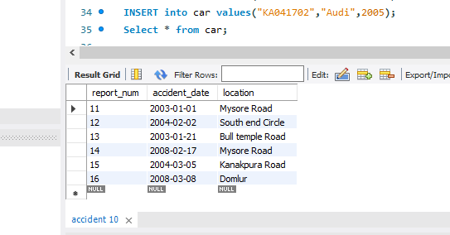

INSERT into car values("KA052250","Indica",1990);

INSERT into car values("KA031181","Lancer",1957);

INSERT into car values("KA095477","Toyota",1998);

INSERT into car values("KA053408","Honda",2008);

INSERT into car values("KA041702","Audi",2005);

Select * from car;

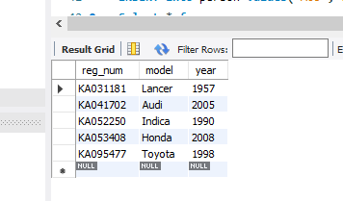

INSERT into person values("A01","Richard","Srinivas nagar");

INSERT into person values("A02","Pradeep","Rajaji nagar");

INSERT into person values("A03","Smith","Ashok nagar");

INSERT into person values("A04","Venu","N R Colony");

INSERT into person values("A05","Jhon","Hanumanth nagar");

Select * from person;

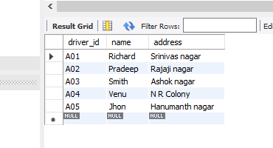

INSERT into owns values("A01","KA052250");

INSERT into owns values("A02","KA053408");

INSERT into owns values("A03","KA031181");

INSERT into owns values("A04","KA095477");

INSERT into owns values("A05","KA041702");

Select * from owns;

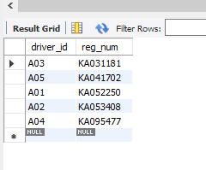

INSERT into participated values("A01","KA052250",11,10000);

INSERT into participated values("A02","KA053408",12,50000);

INSERT into participated values("A03","KA095477",13,25000);

INSERT into participated values("A04","KA031181",14,3000);

INSERT into participated values("A05","KA041702",15,5000);

select * from participated;

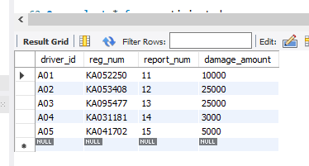

update participated set damage_amount=25000

where reg_num='KA053408' and report_num=12;

select * from participated;



select * from car order by year asc;

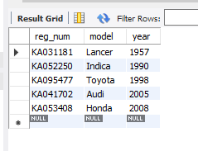

select count(report_num)

from car c, participated p

where c.reg_num=p.reg_num and c.model='Lancer';

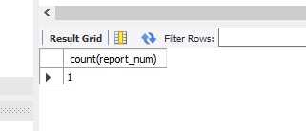

select count(distinct driver_id) CNT

from participated a, accident b

where a.report_num=b.report_num and b.accident_date like '%08%';

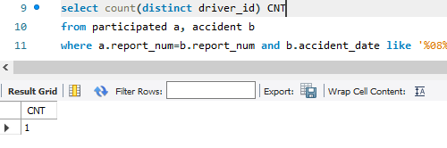

SELECT * FROM participated ORDER BY damage_amount DESC;

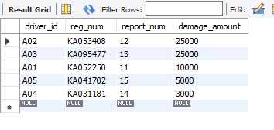

SELECT AVG(damage_amount) FROM participated;

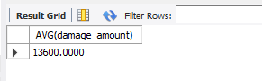

SELECT NAME FROM PERSON A, PARTICIPATED B WHERE A.DRIVER_ID = B.DRIVER_ID

AND DAMAGE_AMOUNT>(SELECT AVG(DAMAGE_AMOUNT) FROM PARTICIPATED);

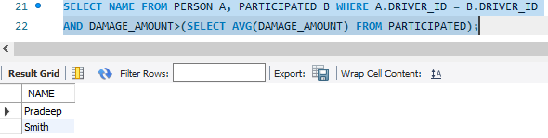

SELECT MAX(DAMAGE_AMOUNT) FROM PARTICIPATED;

